Summary of Benefits and Coverage
: What this Plan Covers & What You Pay for Covered Services Coverage Period: 10/01/2025 - 06/30/2026
Anthem® HealthKeepers Inc. | Coverage for: Individual + Family | Plan Type: POS
Petersburg City Public Schools: Anthem HealthKeepers OA 25 250/30%/5000 Rx $150 ded, $15/$50/$85/20%


The Summary of Benefits and Coverage (SBC) document will help you choose a health plan. The SBC shows you how you and the plan would share the cost for covered health care services. NOTE: Information about the cost of this plan (called the premium) will be provided separately. This is only a summary. For more information about your coverage, or to get a copy of the complete terms of coverage, https://eoc.anthem.com/eocdps/. For general definitions of common terms, such as allowed amount, balance billing, coinsurance, copayment, deductible, provider, or other underlined terms, see the Glossary. You can view the Glossary at www.healthcare.gov/sbc-glossary/ or call (833) 592-9956 to request a copy.

Important Questions | Answers | Why This Matters:
What is the overall deductible? | $250/person or $500/family for In-Network Providers. $1,000/person or $2,000/family for Out-of-Network Providers. | Generally, you must pay all of the costs from providers up to the deductible amount before this plan begins to pay. If you have other family members on the plan, each family member must meet their own individual deductible until the total amount of deductible expenses paid by all family members meets the overall family deductible.
Are there services covered before you meet your deductible? | Yes. Primary Care. Specialist Visit. Preventive Care. Vision Exam. For more information see below. | This plan covers some items and services even if you haven’t yet met the deductible amount. But a copayment or coinsurance may apply. For example, this plan covers certain preventive services without cost sharing and before you meet your deductible. See a list of covered preventive services at https://www.healthcare.gov/coverage/preventive-care-benefits/.
Are there other deductibles for specific services? | Yes. $150/person or $300/family for Prescription Drugs. There are no other specific deductibles. | You must pay all of the costs for these services up to the specific deductible amount before this plan begins to pay for these services.
What is the out-of-pocket limit for this plan? | $5,000/person or $10,000/family for In-Network Providers. $12,500/person or $25,000/family for Out-of-Network Providers. | The out-of-pocket limit is the most you could pay in a year for covered services. If you have other family members in this plan, they have to meet their own out-of-pocket limits until the overall family out-of-pocket limit has been met.
What is not included in the out-of-pocket limit? | Premiums, balance-billing charges, and health care this plan doesn't cover. | Even though you pay these expenses, they don’t count toward the out-of-pocket limit.
Will you pay less if you use a network provider? | Yes. See  www.anthem.com/find-care/?alphaprefix=Z4U  or call (833) 592-9956 for a list of network providers. Costs may vary by site of service and how the provider bills. | This plan uses a provider network. You will pay less if you use a provider in the plan’s network. You will pay the most if you use an Out-of-Network Provider, and you might receive a bill from a provider for the difference between the provider’s charge and what your plan pays (balance billing). Be aware, your network provider might use an Out-of-Network Provider for some services (such as lab work). Check with your provider before you get services.
Do you need a referral to see a specialist? | No. | You can see the specialist you choose without a referral.

 | All copayment and coinsurance costs shown in this chart are after your deductible has been met, if a deductible applies.

Common  Medical Event | Services You May Need | What You Will Pay |  | Limitations, Exceptions, & Other Important Information
Common  Medical Event | Services You May Need | In-Network Provider  (You will pay the least) | Out-of-Network Provider  (You will pay the most) | Limitations, Exceptions, & Other Important Information
If you visit a health care provider’s office or clinic | Primary care visit to treat an injury or illness | EPHC  $15/visit, deductible does not apply  PCP  $25/visit, deductible does not apply | 30% coinsurance | Virtual visits (Telehealth) benefits available.
If you visit a health care provider’s office or clinic | Specialist visit | $50/visit, deductible does not apply | 30% coinsurance | Virtual visits (Telehealth) benefits available.
If you visit a health care provider’s office or clinic | Preventive care/screening/  immunization | No charge | 30% coinsurance | You may have to pay for services that aren't preventive. Ask your provider if the services needed are preventive. Then check what your plan will pay for.
If you have a test | Diagnostic test (x-ray, blood work) | Lab – Office  No charge  X-Ray – Office  30% coinsurance | Lab – Office  30% coinsurance  X-Ray – Office  30% coinsurance | --------none--------
If you have a test | Imaging (CT/PET scans, MRIs) | 30% coinsurance | 30% coinsurance | --------none--------
If you need drugs to treat your illness or condition  More information about prescription drug coverage is available at http://www.anthem.com/pharmacyinformation/ | Typically Generic (Tier 1) | $15/prescription, Prescription Drug deductible does not apply (retail) and $30/prescription, Prescription Drug deductible does not apply (home delivery) | Greater of $15 or 30% coinsurance, Prescription Drug deductible does not apply (retail) and Not covered (home delivery) | For more information, refer to “National Drug List” at http://www.anthem.com/pharmacyinformation/  *See Prescription Drug section.
 | Typically Preferred Brand & Non-Preferred Generic Drugs (Tier 2) | $50/prescription, Prescription Drug deductible applies (retail) and $125/prescription, Prescription Drug deductible applies (home delivery) | Greater of $50 or 30% coinsurance, Prescription Drug deductible applies (retail) and Not covered (home delivery)
 | Typically Non-Preferred Brand and Generic drugs (Tier 3) | $85/prescription, Prescription Drug deductible applies (retail) and $213/prescription, Prescription Drug deductible applies (home delivery) | Greater of $85 or 30% coinsurance, Prescription Drug deductible applies (retail) and Not covered (home delivery)
 | Typically Preferred Specialty (brand and generic) (Tier 4) | 20% coinsurance up to $300/prescription, Prescription Drug deductible applies (retail and home delivery) | 30% coinsurance up to $300/prescription, Prescription Drug deductible applies (retail) and Not covered (home delivery)
If you have outpatient surgery | Facility fee (e.g., ambulatory surgery center) | 30% coinsurance | 30% coinsurance | --------none--------
If you have outpatient surgery | Physician/surgeon fees | 30% coinsurance | 30% coinsurance | --------none--------
If you need immediate medical attention | Emergency room care | 30% coinsurance | Covered as In-Network | --------none--------
If you need immediate medical attention | Emergency medical transportation | 30% coinsurance | Covered as In-Network | Non-emergency Out-of-Network Ambulance Services are limited to $50,000 per trip, does not apply to air ambulance.
If you need immediate medical attention | Urgent care | $50/visit, deductible does not apply | 30% coinsurance | --------none--------
If you have a hospital stay | Facility fee (e.g., hospital room) | 30% coinsurance | 30% coinsurance | 150 days/benefit period for Inpatient rehabilitation and skilled nursing services combined.
If you have a hospital stay | Physician/surgeon fees | 30% coinsurance | 30% coinsurance | --------none--------
If you need mental health, behavioral health, or substance abuse services | Outpatient services | Office Visit  $25/visit, deductible does not apply  Other Outpatient  30% coinsurance | Office Visit  30% coinsurance  Other Outpatient  30% coinsurance | Office Visit  Virtual visits (Telehealth) benefits available.  Other Outpatient  --------none--------
 | Inpatient services | 30% coinsurance | 30% coinsurance | --------none--------
If you are pregnant | Office visits | $300/pregnancy, deductible does not apply | 30% coinsurance | One copayment per pregnancy for both office visits and childbirth/delivery professional services. Maternity care may include tests and services described elsewhere in the SBC (i.e., ultrasound).
If you are pregnant | Childbirth/delivery professional services | $300/pregnancy, deductible does not apply | 30% coinsurance
If you are pregnant | Childbirth/delivery facility services | 30% coinsurance | 30% coinsurance
If you need help recovering or have other special health needs | Home health care | 30% coinsurance | 30% coinsurance | 100 visits/benefit period for Home Health and Private Duty Nursing combined.
 | Rehabilitation services | $25/visit, deductible does not apply | 30% coinsurance | *See Therapy Services section.
 | Habilitation services | $25/visit, deductible does not apply | 30% coinsurance | *See Therapy Services section.
 | Skilled nursing care | 30% coinsurance | 30% coinsurance | 150 days/benefit period for Inpatient rehabilitation and skilled nursing services combined.
 | Durable medical equipment | 30% coinsurance | 30% coinsurance | *See Durable Medical Equipment section.
 | Hospice services | 30% coinsurance | 30% coinsurance | --------none--------
If your child needs dental or eye care | Children’s eye exam | No charge | $0 copayment up to plan's Maximum Allowed Amount | *See Vision Services section.
If your child needs dental or eye care | Children’s glasses | Not covered | Not covered | *See Vision Services section.
If your child needs dental or eye care | Children’s dental check-up | Not covered | Not covered | --------none--------

Excluded Services & Other Covered Services:
Services Your Plan Generally Does NOT Cover (Check your policy or plan document for more information and a list of any other excluded services.)
- Acupuncture  - Cosmetic surgery  - Infertility treatment  - Weight loss programs | - Bariatric surgery  - Dental care (Adult)  - Long-term care | - Children’s dental check-up  - Glasses for a child  - Routine foot care unless medically necessary

Other Covered Services (Limitations may apply to these services. This isn’t a complete list. Please see your plan document.)
- Chiropractic care 30 visits/benefit period  - Private-duty nursing 100 visits/benefit period combined with Home Health | - Hearing aids 1 item/ear every 24 months for children 18 years of age or under. $1,500 maximum/hearing aid.  - Routine eye care (Adult) 1 exam/benefit period | - Most coverage provided outside the United States. See www.bcbsglobalcore.com

Your Rights to Continue Coverage
: There are agencies that can help if you want to continue your coverage after it ends. The contact information for those agencies is: Virginia Bureau of Insurance, 1300 East Main Street, P. O. Box 1157, Richmond, VA 23218, (800) 552-7945, Department of Labor, Employee Benefits Security Administration, (866) 444-EBSA (3272), www.dol.gov/ebsa/healthreform, or contact Anthem at the number on the back of your ID card. Other coverage options may be available to you, too, including buying individual insurance coverage through the Health Insurance Marketplace. For more information about the Marketplace, visit www.HealthCare.gov or call 1-800-318-2596.

Your Grievance and Appeals Rights
: There are agencies that can help if you have a complaint against your plan for a denial of a claim. This complaint is called a grievance or appeal. For more information about your rights, look at the explanation of benefits you will receive for that medical claim. Your plan documents also provide complete information on how to submit a claim, appeal, or a grievance for any reason to your plan. For more information about your rights, this notice, or assistance, contact:
ATTN: Grievances and Appeals, P.O. Box 27401, Richmond, VA 23279
Department of Labor, Employee Benefits Security Administration, (866) 444-EBSA (3272), www.dol.gov/ebsa/healthreform
Virginia Bureau of Insurance, 1300 East Main Street, P. O. Box 1157, Richmond, VA 23218, (800) 552-7945

Does this plan provide Minimum Essential Coverage?
Yes.
Minimum Essential Coverage generally includes plans, health insurance available through the Marketplace or other individual market policies, Medicare, Medicaid, CHIP, TRICARE, and certain other coverage. If you are eligible for certain types of Minimum Essential Coverage, you may not be eligible for the premium tax credit.

Does this plan meet the Minimum Value Standards?
Yes.
If your plan doesn’t meet the Minimum Value Standards, you may be eligible for a premium tax credit to help you pay for a plan through the Marketplace.

To see examples of how this plan might cover costs for a sample medical situation, see the next section.

About these Coverage Examples:
This is not a cost estimator. Treatments shown are just examples of how this plan might cover medical care. Your actual costs will be different depending on the actual care you receive, the prices your providers charge, and many other factors. Focus on the cost-sharing amounts (deductibles, copayments and coinsurance) and excluded services under the plan. Use this information to compare the portion of costs you might pay under different health plans. Please note these coverage examples are based on self-only coverage.

Peg is Having a Baby
(9 months of in-network pre-natal care and a hospital delivery)

The plan’s overall deductible $250
Specialist copayment $50
Hospital (facility) coinsurance 30%
Other coinsurance 0%
This EXAMPLE event includes services
like:
Specialist office visits (prenatal care)
Childbirth/Delivery Professional Services
Childbirth/Delivery Facility Services
Diagnostic tests (ultrasounds and blood work)
Specialist visit (anesthesia)

Total Example Cost | $12,700
In this example, Peg would pay:
Cost Sharing
Deductibles | $250
Copayments | $300
Coinsurance | $2,600
What isn’t covered
Limits or exclusions | $60
The total Peg would pay is | $3,210
Managing Joe’s Type 2 Diabetes
(a year of routine in-network care of a well-controlled condition)

The plan’s overall deductible $250
Specialist copayment $50
Hospital (facility) coinsurance 30%
Other coinsurance 0%
This EXAMPLE event includes services
like:
Primary care physician office visits (including disease education)
Diagnostic tests (blood work)
Prescription drugs
Durable medical equipment (glucose meter)

Total Example Cost | $5,600
In this example, Joe would pay:
Cost Sharing
Deductibles | $150
Copayments | $1,600
Coinsurance | $0
What isn’t covered
Limits or exclusions | $20
The total Joe would pay is | $1,770
Mia’s Simple Fracture
(in-network emergency room visit and follow
up care)

The plan’s overall deductible $250
Specialist copayment $50
Hospital (facility) coinsurance 30%
Other coinsurance 0%
This EXAMPLE event includes services
like:
Emergency room care (including medical supplies)
Diagnostic test (x-ray)
Durable medical equipment (crutches)
Rehabilitation services (physical therapy)

Total Example Cost | $2,800
In this example, Mia would pay:
Cost Sharing
Deductibles | $250
Copayments | $300
Coinsurance | $600
What isn’t covered
Limits or exclusions | $0
The total Mia would pay is | $1,150

We’re here for you – in many languages
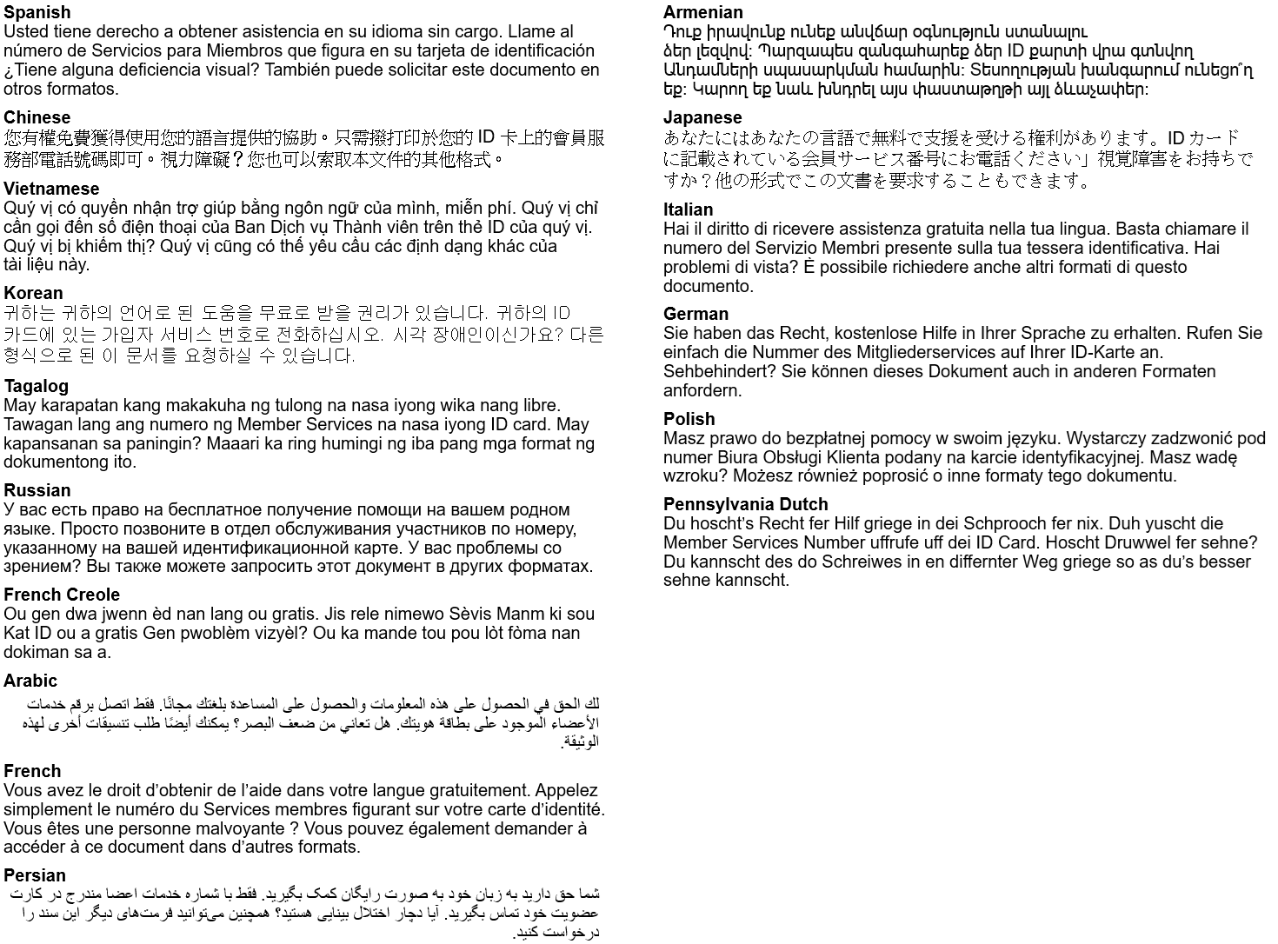
The law requires us to include a message in all of these different languages. Curious what they say? Here’s the English version: “You have the right to get help in your language for free. Just call the Member Services number on your ID card.” Visually impaired? You can also ask for other formats of this document

TTY/TTD:711

It’s important we treat you fairly
We follow federal civil rights laws in our health programs and activities. Members can get reasonable modifications as well as free auxiliary aids and services if you have a disability. We don’t discriminate, on the basis of race, color, national origin, sex, age or disability. For people whose primary language isn’t English (or have limited proficiency), we offer free language assistance services like interpreters and other written languages. Interested in these services? Call the Member Services number on your ID card for help (TTY/TDD: 711) or visit our website. If you think we failed in any areas or to learn more about grievance procedures, you can mail a complaint to: Compliance Coordinator, P.O. Box 27401, Richmond, VA 23279, or directly to the U.S. Department of Health and Human Services, Office for Civil Rights at 200 Independence Avenue, SW; Room 509F, HHH Building; Washington, D.C. 20201. You can also call 1-800- 368-1019 (TDD: 1-800-537-7697) or visit https://ocrportal.hhs.gov/ocr/portal/lobby.jsf

